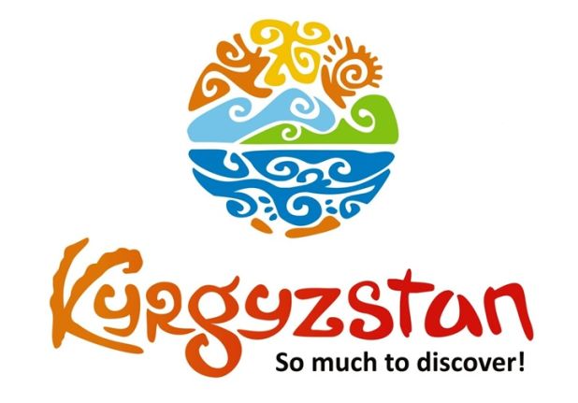**World Nomad Games 2018**

Country: **Kyrgyzstan**

Period: fixed dates **September 1, 2018 – September 8, 2018**

**Days: 8 / Nights: 7**

Organizing any complexity of tours to Issyk-Kul, Son-Kul, around Kyrgyzstan and Central Asia. We guarantee you high quality of service and individual approach!

This year Kyrgyzstan will host the most grandiose event of 2018 in Central Asia: World Nomad Games. It is really the most discussed and at the same time the most exclusive event in the world of nomadic countries.

First two times it was also held in Kyrgyzstan and it became so popular, that the last time not only post soviet mass media covered it, but also a top news websites as **Atlantic** and **Guardian** wrote about it. And we must accept: it was unbelievable!

We offer you a tour, which will let you know and see unique places and culture of Kyrgyz people, and to spend couple days in the center of World Nomad Games and festival itself.

**Day 1: Arrival to Bishkek**

On the first day after lunch in a local cafe you will have a city tour of Bishkek including all main historical and amusement places. It will finish by excursion to colorful market Osh Bazar to feel the real sense of Central Asian life by watching merchants selling their products, people of all ages and different ethnic groups, nationalities who live in Kyrgyzstan.

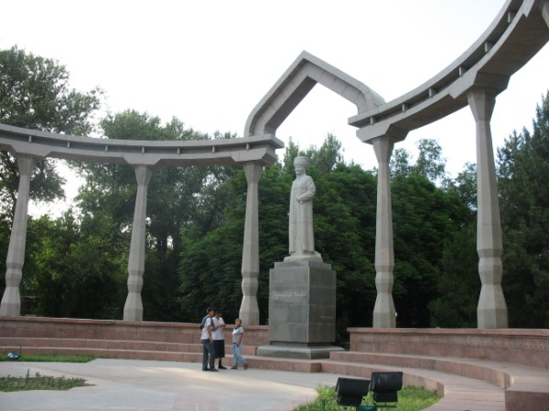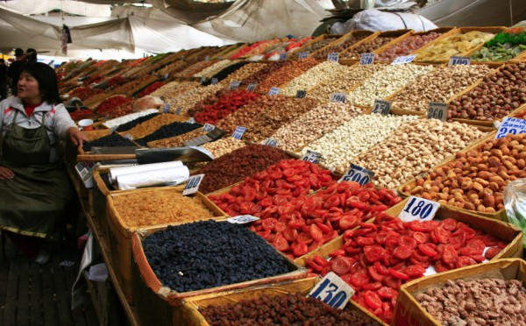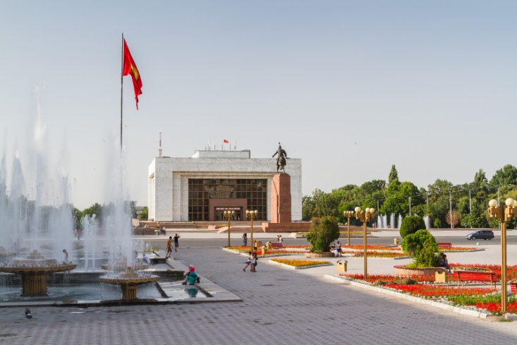

**Day 2: Bishkek - Issyk Kul (285 km/5 h)**

Departure to Issyk-Kul with en-route stop in Tokmak to visit remains of ancient city Balasagyn with a minaret, an open air museum of Balbals and a small archeological museum.

Upon arrival to Cholpon-Ata visit open air Museum of Petroglyph’s (stone inscriptions)

Rukh-Ordo cultural complex and Regional Museum. Lunch in a local cafe.

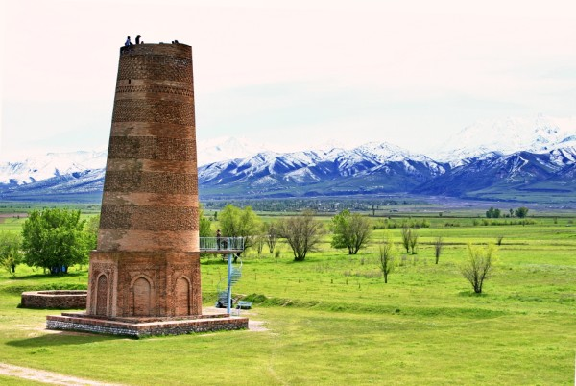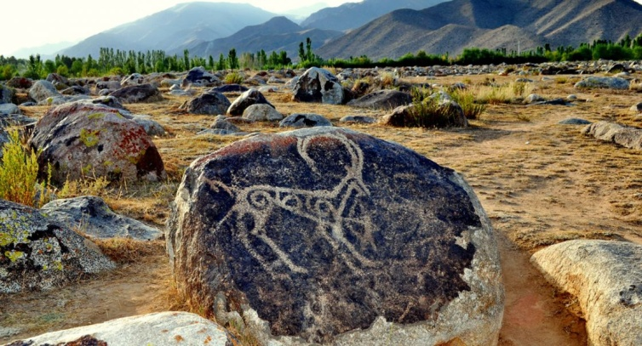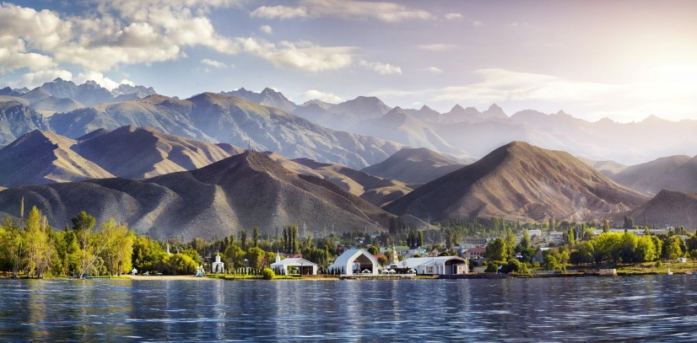

*In the evening we will attend World Nomad Games opening ceremony.*

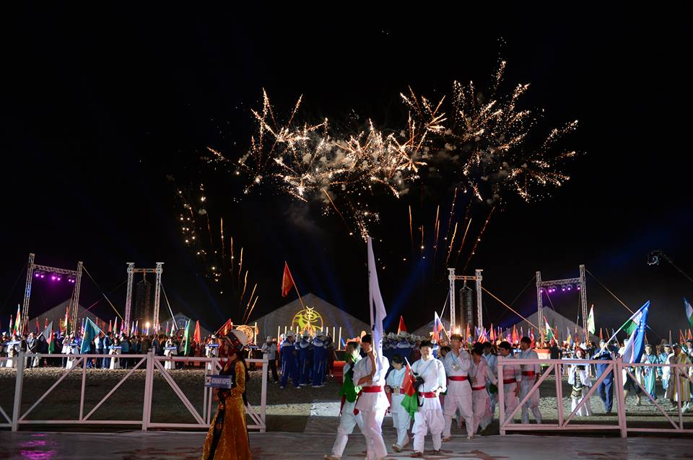

**Day 3: Cholpon-Ata**

Today you will be transferred to Kyrchyn jailoo (Semenov Gorge) where the Kyrgyz village will be settled during the festival. In the afternoon you will visit games that are planned in Cholpon-Ata right on the shore of the Issyk-Kul Lake.

Full day on a World Nomad Games!

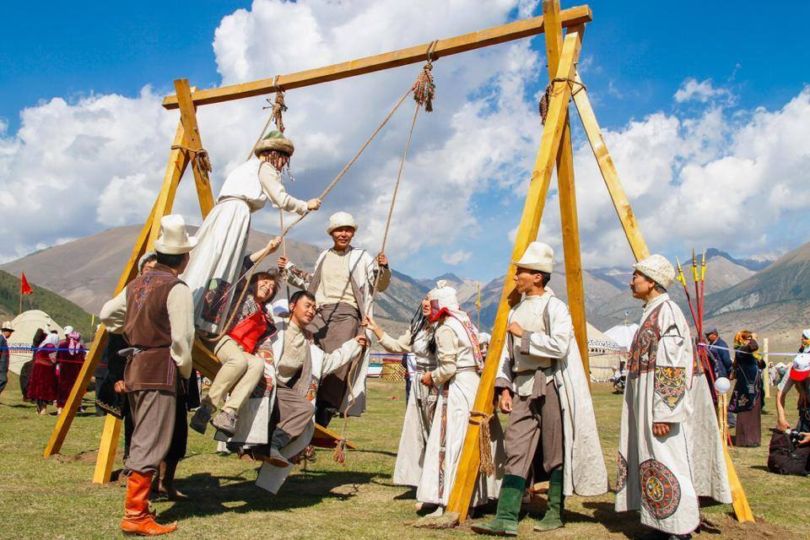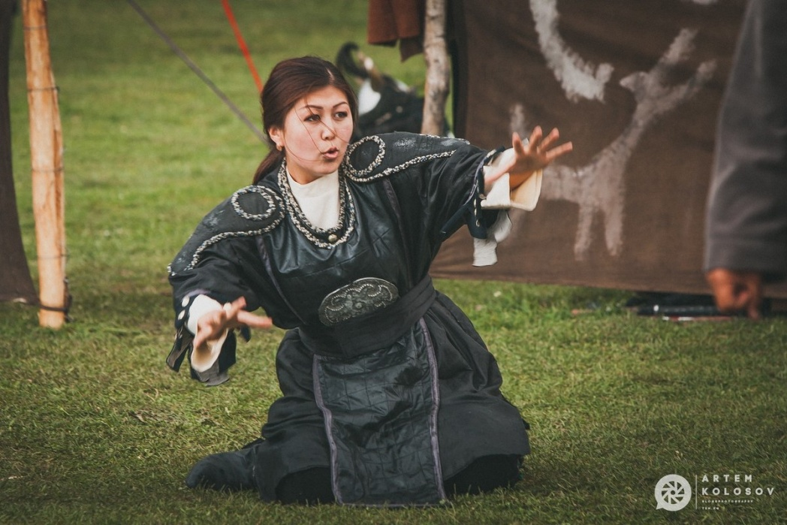

**Day 4: CholponAta - Karakol (150 km/3 h)**

On this day you will enjoy the scenic road to Karakol town located at Far East part of the lake. On the way visit a farm called Reina-Kench at Tepke village. Upon arrival to the farm you will have a guided tour by the farmer who will show you his stable where he keeps racing horses, animal farm, and gardening. Afterwards, you will be offered lunch inside or outside depending on weather condition. Lunch is prepared from eco products from the farm. Upon arrival to Karakol you will have a short sightseeing tour.

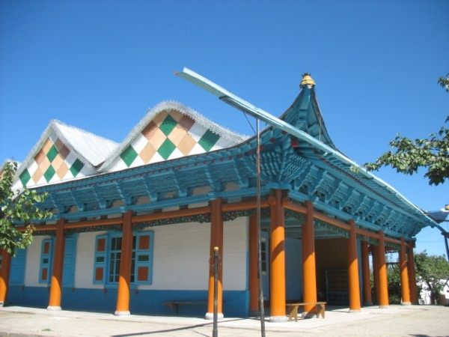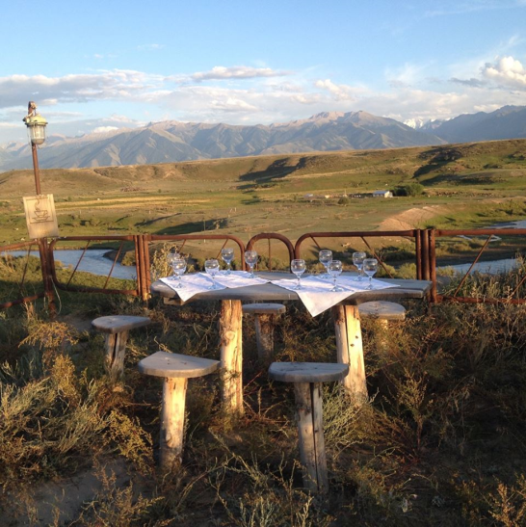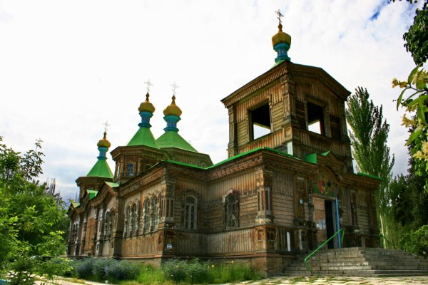

We will also visit Przewalski Museum – a Soviet renowned explorer of Central and Eastern Asia. Then we have a visit to the old wooden Dungan Mosque built without nails, old wooden Russian Church and One Village-One Product local shop.

**Day 5: Karakol - Jyrgalan (75 km/1 h)**

After strengthening breakfast at guest house we will depart to Jyrgalan valley. We will meet with locals who will great you there and take you to their homes. After guided tour around the village you will participate in a whole process of cooking Kyrgyz type of bread Boorso. Afterwards, taste freshly cooked boorsoks with jam/honey over the tea. You will participate in cooking homemade food and have lunch together with the family who will tell stories of that region.

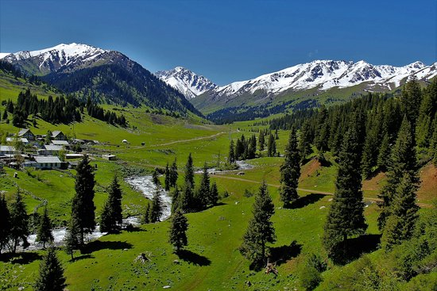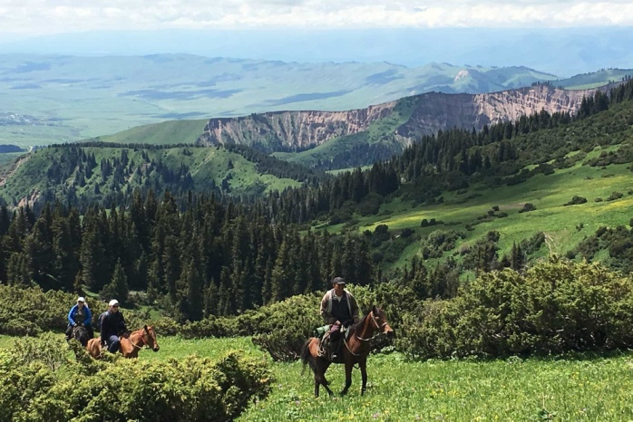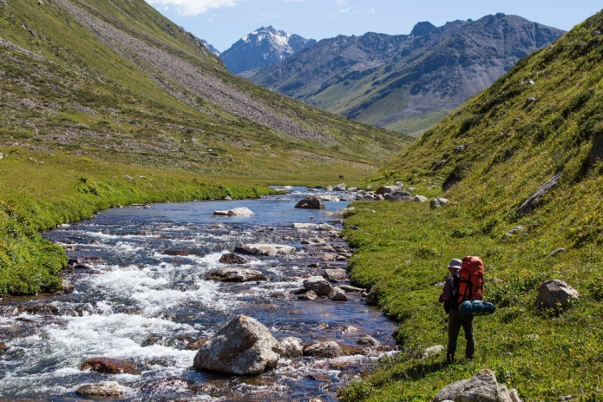

**Day 6: Jyrgalan - Chon-Kemin (380 km/7 h)**

After breakfast drive to Jeti-Ogyz, a lush valley with some striking red sandstone rock formations including the “Seven Bulls” from which the valley takes its name. It is also possible to visit a spa built during Soviet time and still in operating.

Also visit Skazka (Fairy Tale) Canyon. The canyon was named due to its bizarre rocky landscape, which for many years has been transformed by wind into fabulous sculptures and formations. Because the different rocks have amazing colors, the rocky statues not only have unusual shapes, but also magical colors.

Upon arrival to village, accommodation at family-run friendly guesthouse

After delicious home cooked dinner, enjoy a walking excursion around the village and the valley to introduce with countryside natural beauty and local people.

Dinner in GH will be followed with folklore performance by villagers.

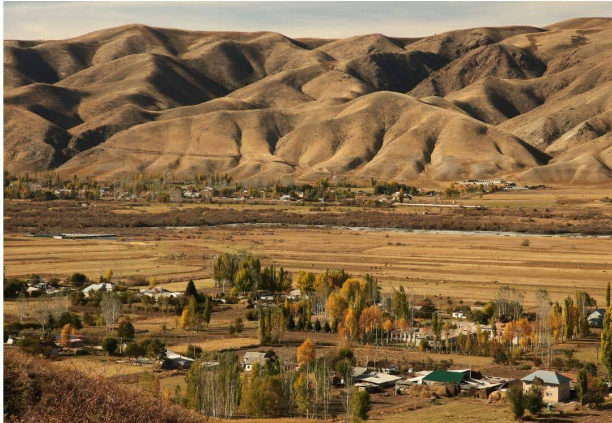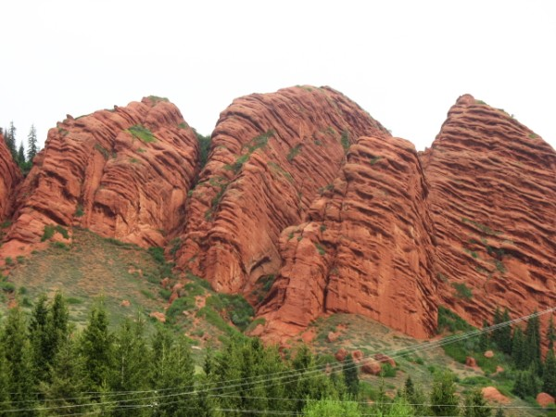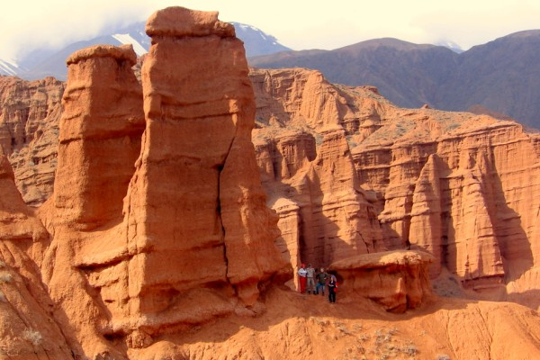

**Day 7: Chon-Kemin – Bishkek (145 km/3 h)**

After breakfast depart for whole-day horseback riding tour to Kalmak-Ashuu Gorge. Arrival to guesthouse and lunch. After some rest depart back to Bishkek. Drop-off in the city.

Arrival to Bishkek late in the afternoon, check-in to hotel.

Farewell dinner at a local restaurant.

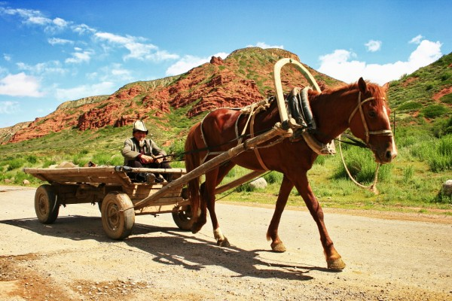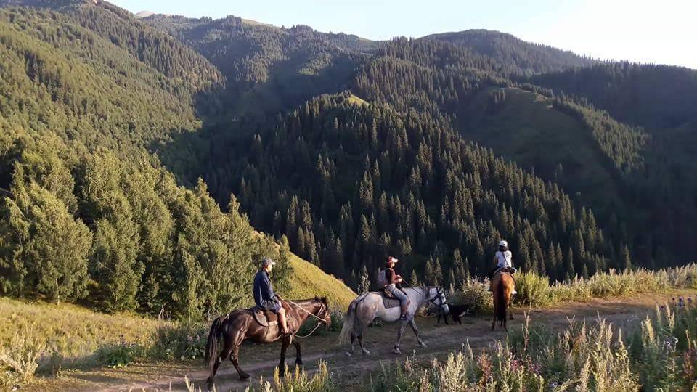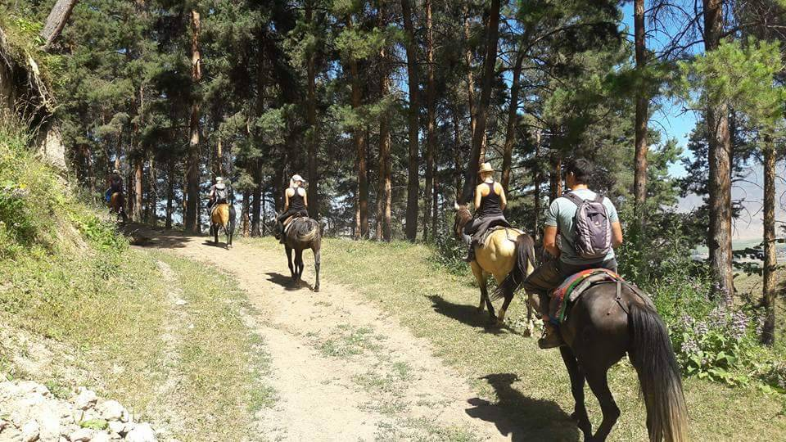

**Day 8: Departure from Bishkek**

Breakfast at the hotel and transfer to the airport to your flight.

| **GROUP SIZE** | **PRICE IN USD/PER PERSON** |
| --- | --- |
| 5 | 1052 USD |
| Supplementary for single accommodation | 275 USD |

**The price is guaranteed with minimum 5 people in the group**  
For individual departures, please, contact us at [info@travelscruiser.com](mailto:info@travelscruiser.com)  

| **TOUR PRICE INCLUDES** |  |
| --- | --- |
| Accommodation - twin based | Bishkek - 3* hotel (2 o/n) Issyk-Kul - 3* hotel (2 o/n) Karakol - guest house (1 o/n) Jyrgalan - guest house (1 o/n) Chon-Kemin - guest house (1/n) |
| Transport | Land transportation by air-conditioned non-smoking vehicle |
| Guide services (Eng/Russ) | Included |
| Meals | 7 breakfasts, 4 lunches, 4 dinners |
| Entrance fees to museums | Included |
| Bottled water | 1 liter/person/day |
| Folklore show in Chon-Kemin | Included |
| Boorsok cooking show | Included |

| **TOUR PRICE EXCLUDES** |  |
| --- | --- |
| International air fare | Not included |
| Visa to Kyrgyzstan/Visa support/Passport registration (if required) | Not included |
| Entrance fees to the opening ceremony | from 85 USD/per person |
| Felt show | 55 USD for the show |
| Personal expenses | Not included |

**Contact information:**

[www.travelscruiser.com](http://www.travelscruiser.com)

Phone (24/7): +996 …………., +996 ……….

E-mail: [info@travelscruiser.com](mailto:info@travelscruiser.com)